**Experiment No. 1.3**

1. **Aim/Overview of the practical:**

Create a webpage and publish on Azure using FileZilla.

1. **Code for practical:**

* Create a file using HTML, CSS and JS in VS Code Editor or any other IDE or Text Editor.
* Now download FileZilla software from official website.
* Now open Azure Portal and click on “***Create Static WebApp”***. Provide Name and Select plan for WebApp.
* Click on “***Review + Create”*** button to deploy your WebApp.

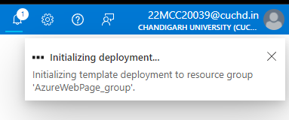

* Open your WebApp and click on “**Download Publish File**”.
* Open File with notepad.
* Open FileZilla and click on File > Site Manager.

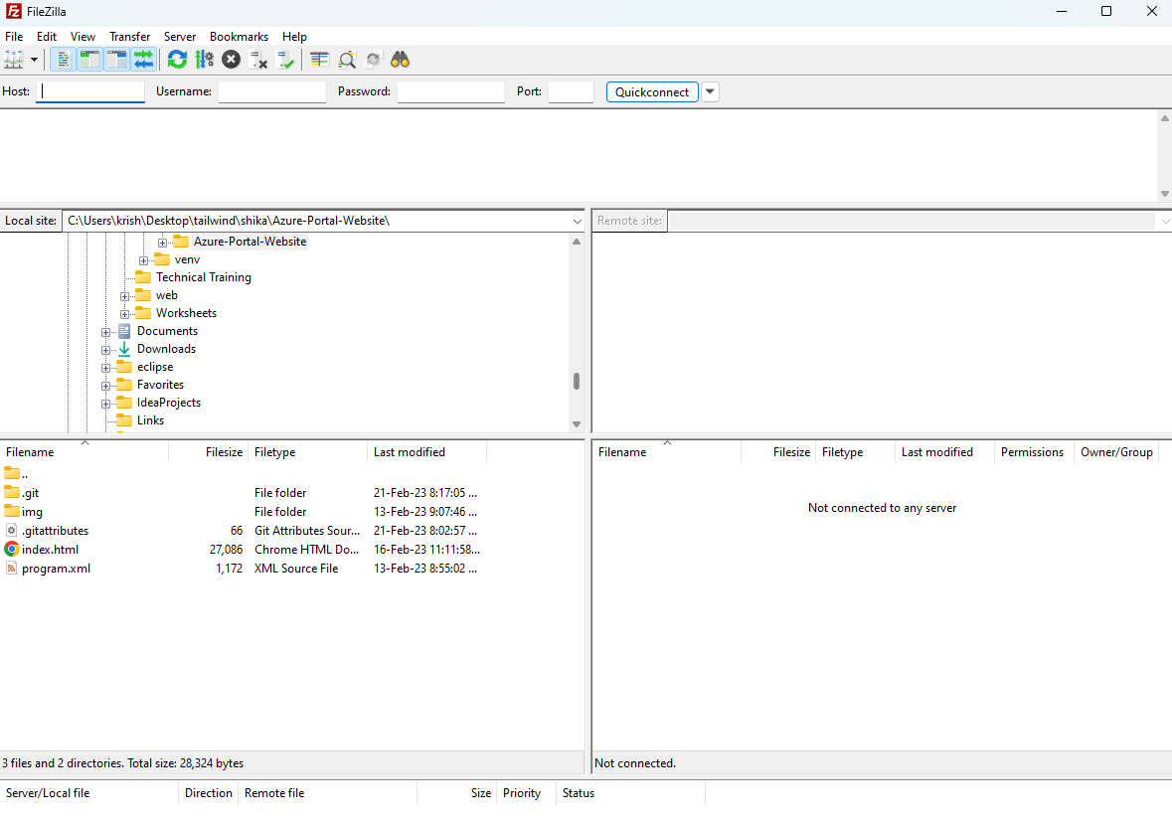

* Click on New site.
* Enter Host URL, Username and Password and click on OK.

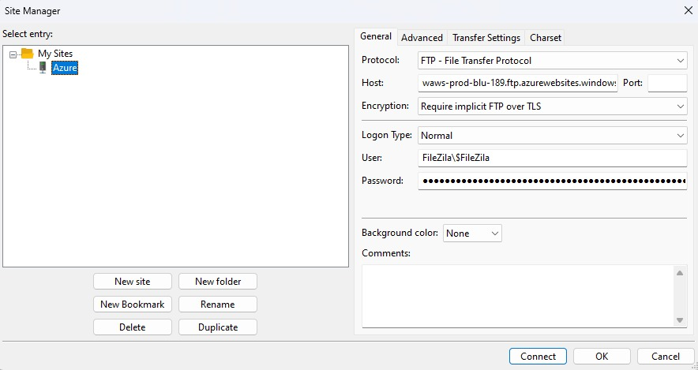

* Now click on Site Manager and select your site and click on **Connect** button.
* Now select the files you want to deploy and right click and click on **Upload** button.

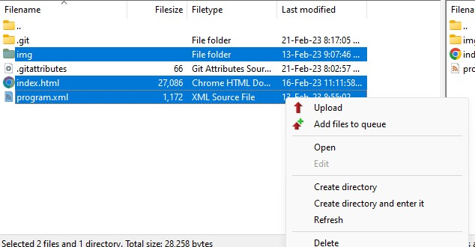

* You can delete the default html template if you want.
* Open Azure portal and click on your WebApp dashboard.
* Click on ***Browse*** button or click on URL to view your deployed website.



**************************************** **THE END** ***********************************************